**Introduction of Active and Passive Components and Verification of Kirchhoff’s Laws using circuit simulation**

**Name: Adwait S Purao**

**UID:** 2021300101

**Branch:** Computer Engineering

**Batch:** B2

**OBSEVATION TABLE:**

1. **Resistance**

|  |  |  |  |
| --- | --- | --- | --- |
| **Sr. No.** | **Value of R using colour code** | **Value of R using multimeter** | **%Error** |
| 1 | 22 * 102 ±5% | 22.2 * 102 | -0.9% |
| 2 | 10 * 102 ±5% | 9.98 * 102 | 0.2% |

1. **Inductor**

|  |  |  |
| --- | --- | --- |
| **Sr. No.** | **Value of L using colour code** | **Type of Inductor** |
| 1 | 10 * 103 | Axial |
| 2 | 56 * 102 | Axial |

1. **Capacitor**

|  |  |  |
| --- | --- | --- |
| **Sr. No.** | **Value of C** | **Type of Capacitor** |
| 1 | 100 * 10-6 | Electrolytic |
| 2 | 1000 * 10-6 | Electrolytic |
| 3 | 104 * 10-9 | Paper |
| 4 | 224 * 10-9 | Paper |

1. **Active Components**

|  |  |  |  |  |
| --- | --- | --- | --- | --- |
| **Sr. No.** | **Name of the**  **component** | **Symbol** | **Identification of pins form observation** | **No. printed on component to refer datasheet** |
| 1 | Transistor |  | Emitter, Base, Collector | BC547 K944 |
| 2 | Diode |  | Anode, Cathode | IN4007 |

**EXPERIMENT No: 1** **DATE: 20 / 6 / 2022**

# Introduction of Active and Passive Components & Verification of Kirchoff's Laws using circuit simulation

**AIM:**

1. To differentiate active and passive components from the given components.
2. To identify the value of resistors using colour codes and wattage according to size of the resistors. Also verify the value using multimeter.
3. To find different types of capacitors and their values.
4. To identify the pins of transistor and diodes.
5. To verify Kirchhoff’s Laws using circuit simulation with the help of SEQUEL.

**APPARATURUS & COMPONENTS REQUIRED:**

Different active and passive components, Digital Multimeter, Sequel simulator

**THEORY: Write theory related with following questions.**

1. Define active and passive components. Give examples of each.
2. Write statement of Kirchhoff's laws.

**Procedure:**

1. Find the value of given resistors using color code also verify it using given multimeter.
2. Find the value of the given inductor.
3. Find the value of given capacitor also identify types of capacitors.
4. Identify the terminals in case of Diode and Transistor. Also write down the number given on transistor and diode and refer its datasheet.
5. Download SEQUEL Simulator.
6. For verification of Kirchhoff's Laws, built the circuit in simulator.
7. Simulate the circuit and obtain current flowing through each resistor and voltage across each resistor.
8. Verify the result using Kirchhoff’s current equation for the respective node.
9. Verify the result using Kirchhoff’s voltage equation for the present 3 loops in the circuit.
10. Verify them with theoretical values.

**Active components:** An active component is an electronic component which supplies energy to a circuit.

**Eg.** Voltage sources, Current sources. Generators (such as alternators and DC generators), All different types of transistors (such as bipolar junction transistors, MOSFETS, FETs, and JFET).,Diodes (such as Zener diodes, photodiodes, Schottky diodes, and LEDs)

**Passive components:** A passive component is an electronic component which can only receive energy, which it can either dissipate, absorb or store it in an electric field or a magnetic field. Passive elements do not need any form of electrical power to operate.

**Eg.** Resistors, Inductors, Capacitors, Transformers

**Kirchhoff’s laws:**

* **Kirchhoff’s current law:** Kirchhoff’s Current Law states that the total current entering a junction or a node equals the charge leaving the node as no charge is lost.
* **Kirchhoff’s voltage law:** Kirchhoff’s voltage law states that the voltage around a loop equals the sum of every voltage drop in the same loop for any closed network and equals zero.

**CIRCUIT DIAGRAM:**

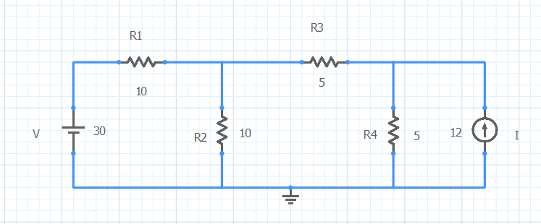

**Sequel Implementation**

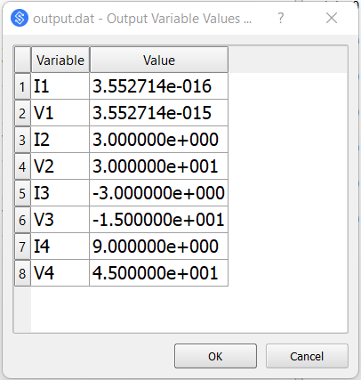

**Sequel Output**

**OBSERVATION TABLE:**

|  |  |  |  |
| --- | --- | --- | --- |
| **V1(Volts)** | **V2(Volts)** | **V3(Volts)** | **V4(Volts)** |
| 0 | 30 | -15 | 45 |
|  |  |  |  |
| **I1(A)** | **I2(A)** | **I3(A)** | **I4(A)** |
| 0 | 3 | -3 | 9 |

**CALCULATIONS:**

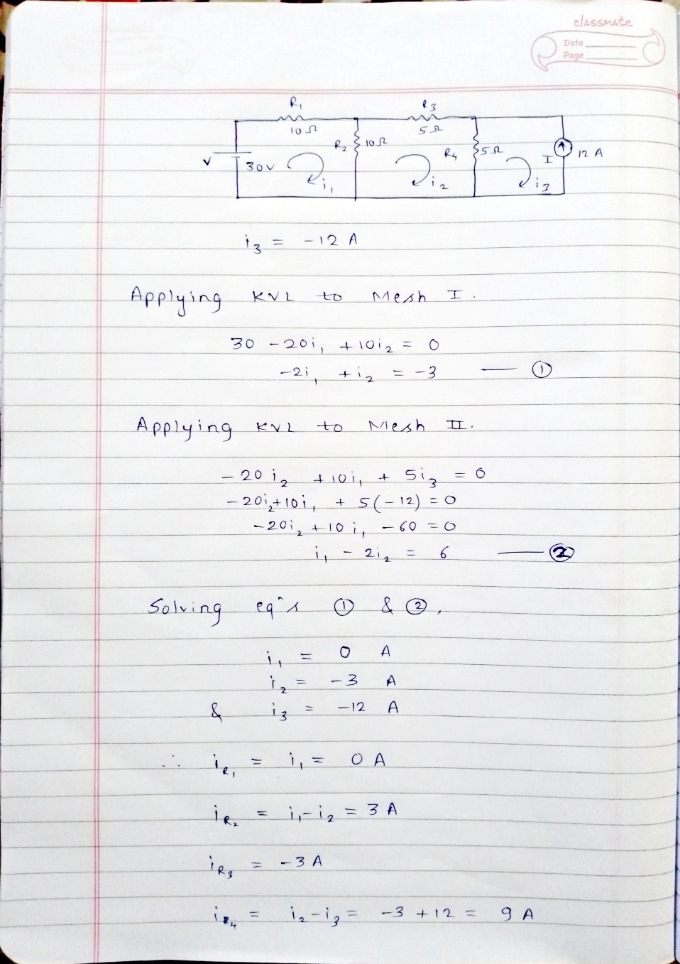

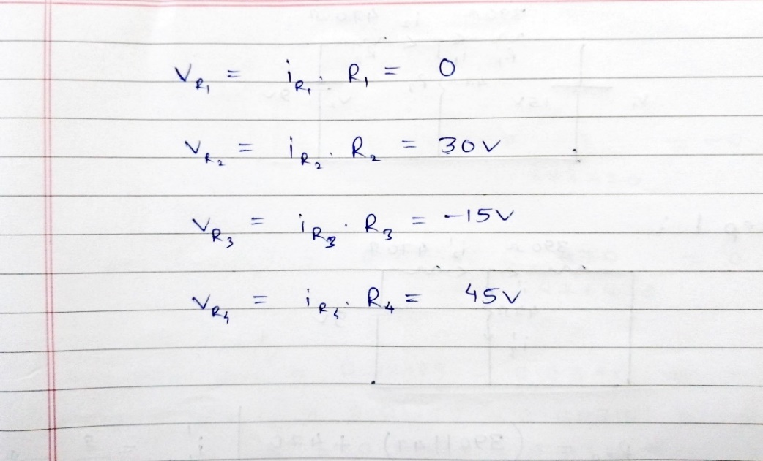

**RESULT:**

|  |  |  |  |  |  |  |  |
| --- | --- | --- | --- | --- | --- | --- | --- |
| **V1(Volts)** | | **V2(Volts)** | | **V3(Volts)** | | **V4(Volts)** | |
| **Theoretical** | **By simulation** | **Theoretical** | **By simulation** | **Theoretical** | **By simulation** | **Theoretical** | **By simulation** |
| 0 | 0 | 30 | 30 | -15 | -15 | 45 | 45 |

|  |  |  |  |  |  |  |  |
| --- | --- | --- | --- | --- | --- | --- | --- |
| **I1(A)** | | **I2(A)** | | **I3(A)** | | **I4(A)** | |
| **Theoretical** | **By simulation** | **Theoretical** | **By simulation** | **Theoretical** | **By simulation** | **Theoretical** | **By simulation** |
| 0 | 0 | 3 | 3 | -3 | -3 | 9 | 9 |

**CONCLUSION:**

